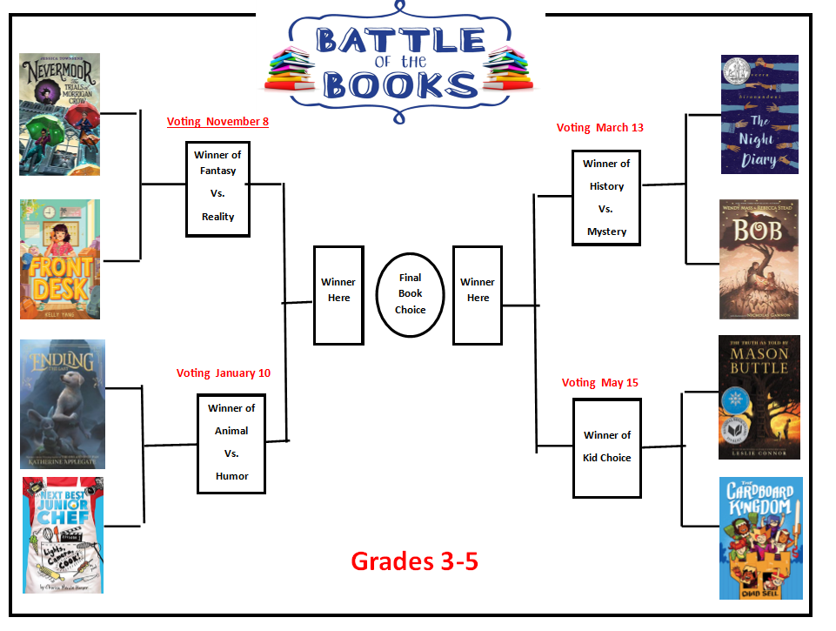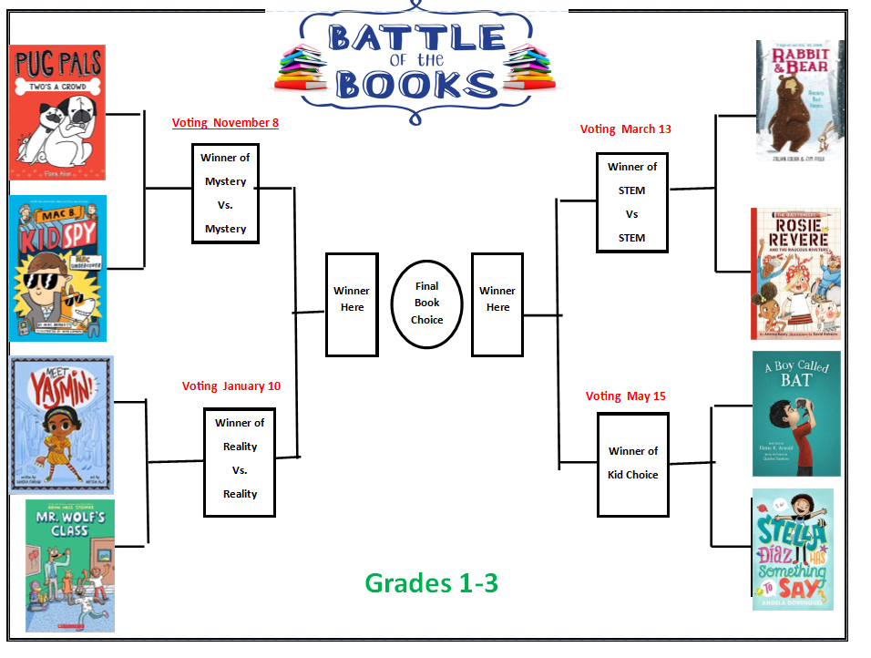

Battle of the Books Grades 3-5
Title | Author
Nevermoor | Jessica Townsend
Front Desk | Kelly Yang
Next Best Junior Chef | Charise Mericle Harper
Endling the Last | Katherine Applegate
Bob | Wendy Mass & Rebecca Stead
The Night Diary | Veera Hiranandani
The Truth as Told by Mason Buttle | Leslie Connor
The Cardboard Kingdom | Chad Sell

Battle of the Books Grades 1-3
Title | Author
Pug Pals Two’s a Crowd | Flora Ahn
Mac B. Kid Spy Mac Undercover | Mac Barnett
Meet Yasmin | Saadia Faruqi
Mr. Wolf’s Class | Aron Nels Steinke
Rosie Revere and the Raucous Riveters | Andrea Beaty
Rabbit and Bear Rabbit’s Bad Habits | Julian Gough & Jim Field
A Boy Called BAT | Elana K. Arnold
Stella Diaz Has Something to Say | Angela Dominiguez

